

Company Flash Screen



Introduction



Login

Automatically the game will detect if the device is online or offline.

If offline, multiplayer is deactivated but can still play the game in single player.

If you have played the game in offline and gain points, this will be automatically updated when the device is online.

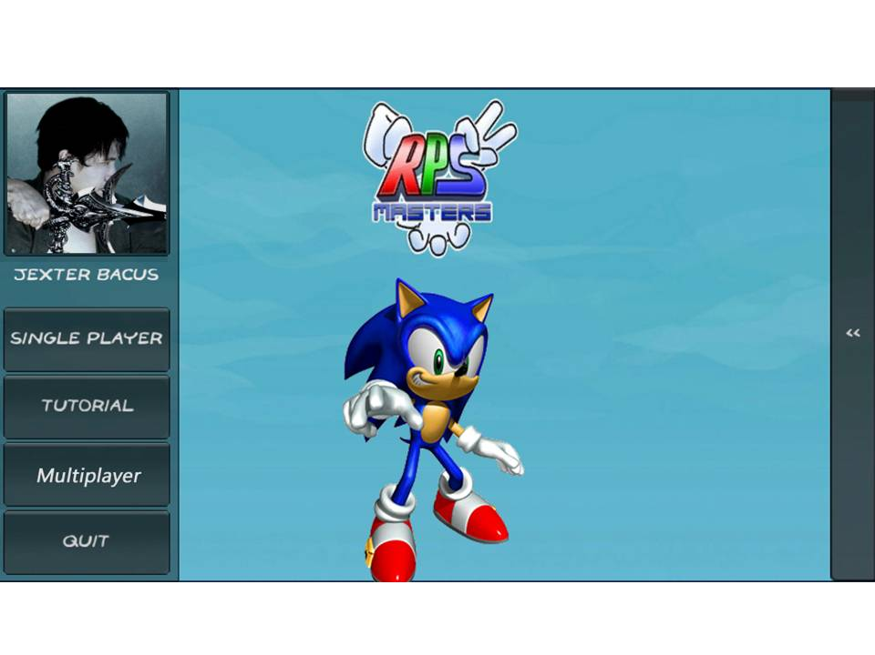

Main Menu